Gen2 Oscillator Firmware Upgrade

This document describes field upgrading of the Gen2 Oscillator firmware using the USB connection.

1. Connect a USB to the Gen2 Oscillator, open Tera Term and verify communication with it and note which COM port it connects to.
2. Close Tera Term
3. Open the Gen2_Oscillator_FW_Upgrade folder in Windows Explorer and double click on **program_master_fw.bat**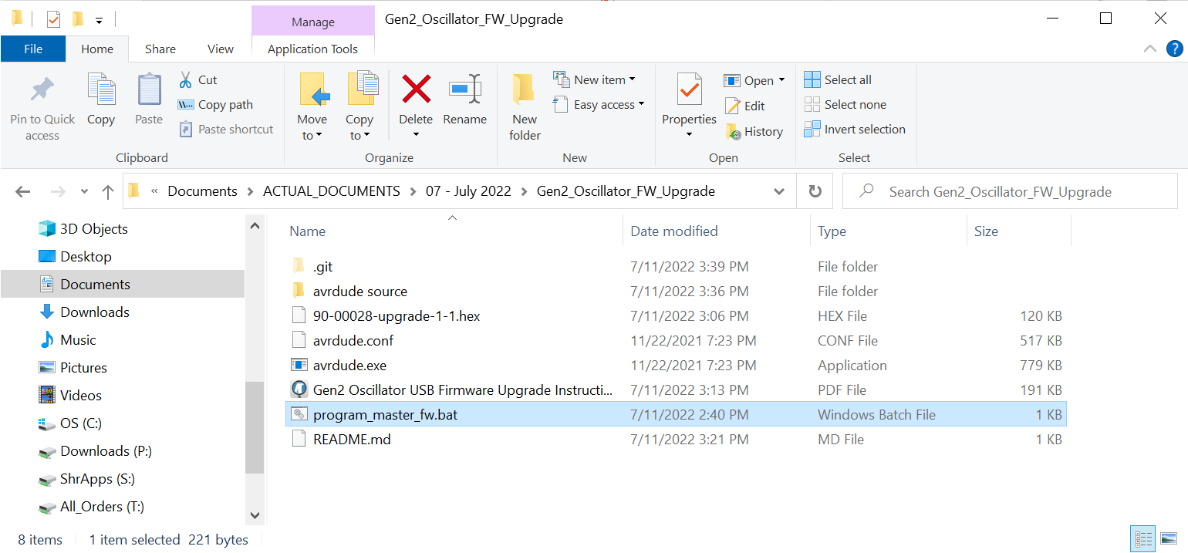
4. Enter the COM port number as shown.   
   **Don’t press Enter yet. Follow the instructions of steps 5 & 6 for when to press Enter.**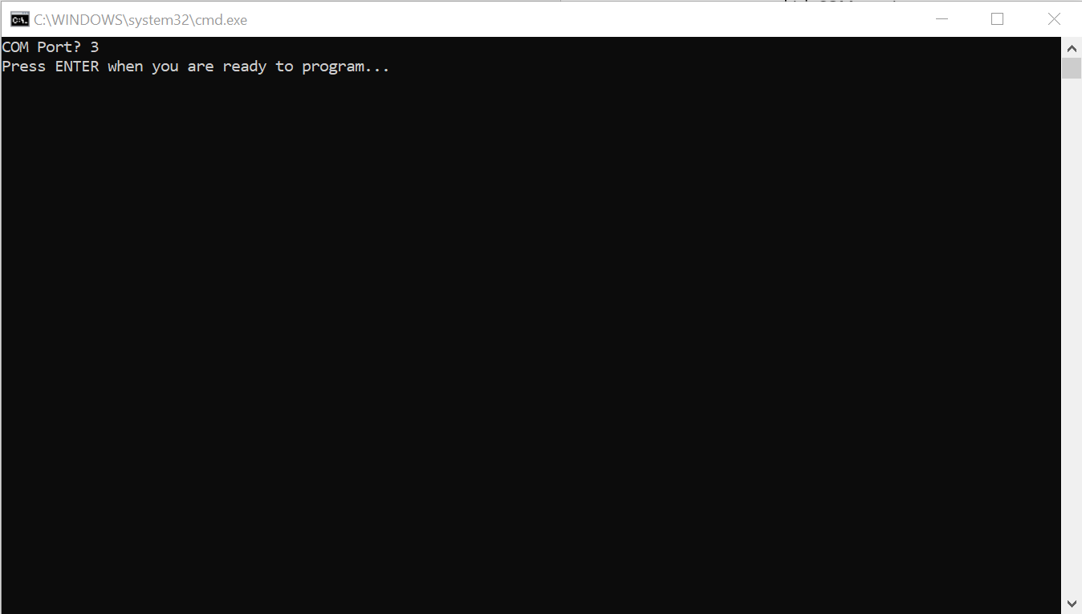
5. Turn off the Gen2 Oscillator.
6. Turn on the Gen2 Oscillator and at the same time Press <Enter> in the command prompt window.  
   The utility should recognize the Gen2 Oscillator and upgrade the firmware.